Figure 1. Forest structural diversity may influence soil microbial diversity through several pathways. A less structurally diverse forest (A) may support lower soil microbial diversity due to lower productivity and belowground carbon allocation, less coarse woody debris, and less complex rooting architecture relative to that of a more structurally diverse stand (B). Shapes indicate different microbial taxa.

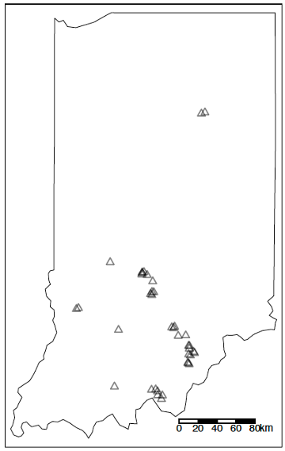

Figure 2. Location of study sites within the central hardwood region of Indiana, USA (N_{Plots} = 38).

Figure 3. Relationship between vegetation area index (VAI) and alpha diversity of EM fungi, AM fungi, all bacteria, and all fungi, calculated with the inverse Simpson’s index. Points represent measured values of microbial richness at 0-5 cm and 5-10 cm soil depths and VAI of plots in forests across Indiana; solid line represents the marginal effect of VAI independent of the effects of other structural diversity variables, and is plotted only for soil depths where the relationship was significant (α=0.05; Table 2).

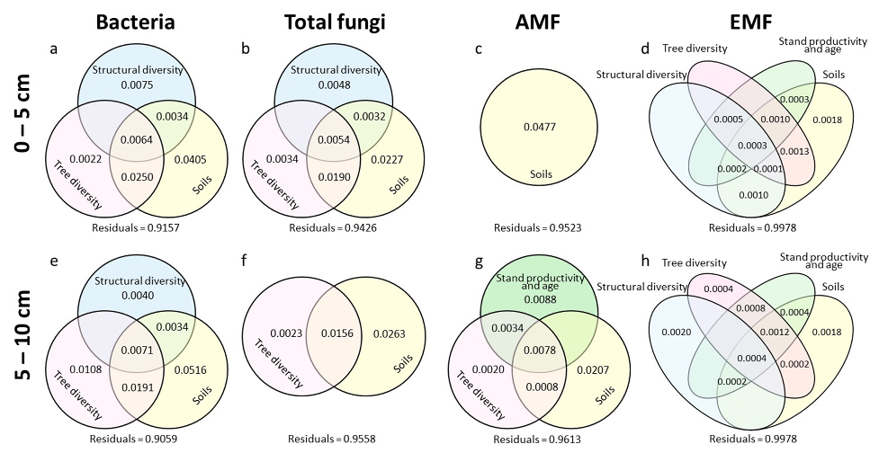

Figure 4. Variance explained by each category of predictors that were indicated significant (p < 0.05) in the dbRDA model at 0-5 cm (a-d) and 5-10 cm (e-h) soil depths for bacterial community (a,e), total fungal community (b,f), AMF community (c,g), and EMF community (d,h). See Table S2 for model X² and p-values for each significant predictor category.

